# **Problems #46 to #50**

===================================

# **Problem 46**

===================

Description: Write A Program: Print Letters From A To Z

=========================================

#include <iostream>

using namespace std;

void PrintLettersAtoZ(){

for(int i = 65; i <= 90; i ++){

cout<< char(i)<<" ";

}

}

int main(){

PrintLettersAtoZ();

return 0;

}

=====================================================================

The OutPut:

==========

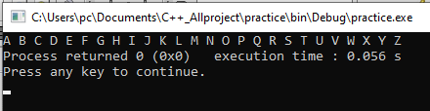

=====================================================================

# **Problem 47**

===========================

Description: Write A Program: Loan Installment month;

=======================================

#include <iostream>

using namespace std;

float ReadPositiveNumber(string Message){

float Number = 0;

do{

cout<<Message<<endl;

cin>>Number;

}while(Number <0);

return Number;

}

float TotalMonths(float LoanAmount, float MonthlyInstallment){

return (float)LoanAmount / MonthlyInstallment;

}

int main(){

float LoanAmount = ReadPositiveNumber("Please Enter Loan Amount: ");

float MonthlyInstallment = ReadPositiveNumber("Enter Monthly Installment: ");

cout<<"\nTotal Month Pay = "<<TotalMonths(LoanAmount,MonthlyInstallment);

cout<<endl;

return 0;

}

=====================================================================  
The OutPut:

=========

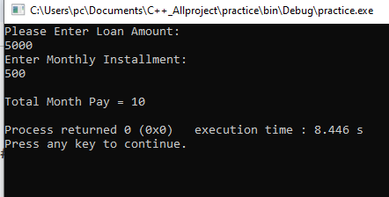

=====================================================================

# **Problem 48**

===================

Description: Write A program: Monthly Loan Installment

========================================

#include <iostream>

using namespace std;

float ReadPositiveNumber(string Message){

float Number = 0;

do{

cout<<Message<<endl;

cin>>Number;

}while(Number <0);

return Number;

}

float MonthlyInstalment(float LoanAmount, float HowManyMonths){

return (float)LoanAmount / HowManyMonths;

}

int main(){

float LoanAmount = ReadPositiveNumber("Please Enter Loan Amount: ");

float HowManyMonths = ReadPositiveNumber("How Many Month: ");

cout<<"\nMonthly Installment = "<<MonthlyInstalment(LoanAmount,HowManyMonths);

cout<<endl;

return 0;

}

=====================================================================

The Output:

===========

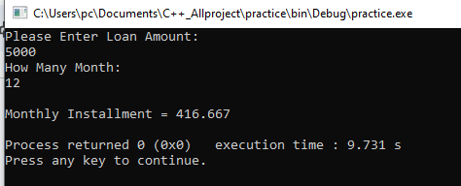

=====================================================================

# **Problem 49**

==================

Description: Write A Program: ATM PIN

=============================

#include <iostream>

using namespace std;

string ReadPinCode(){

string PinCode;

cout<<"Please Enter Pin Code\n";

cin>> PinCode;

return PinCode;

}

bool Login(){

string Pincode;

do{

Pincode = ReadPinCode();

if(Pincode == "1234"){

return 1;

}

else{

cout<<"\nWrong PIN\n";

system("color 4F");

}

}while(Pincode != "1234");

}

int main(){

if(Login()){

system("color 2F");

cout<<"\nYour Balance is: "<< 7500<<'\n';

};

return 0;

}

=====================================================================

The Output

=========

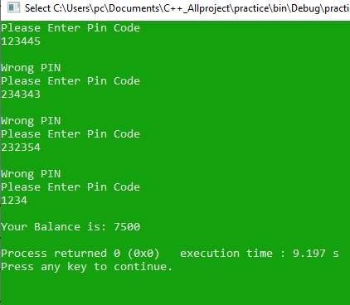

=====================================================================

# **Problem 50**

=====================

Description: Write A Program: ATM 3 PIN Times

===================================

#include <iostream>

using namespace std;

string ReadPinCode(){

string PinCode;

cout<<"Please Enter Pin Code\n";

cin>> PinCode;

return PinCode;

}

bool Login(){

string Pincode;

Short Counter = 3;

do{

Counter --;

Pincode = ReadPinCode();

if(Pincode == "1234"){

return 1;

}

else{

system("color 4F");

cout<<"\nWrong Code, You Have "<< Counter<<" More Tries \n";

}

}while(Pincode != "1234");

}

int main(){

if(Login()){

system("color 2F");

cout<<"\nYour Balance is: "<< 7500<<'\n';

}

else{

cout<<"\nYour Card Blocked Call The Bank For Help. \n";

}

return 0;

}

=====================================================================

The Output

==========

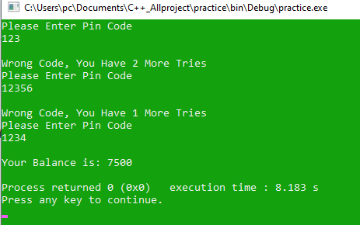

=====================================================================

That’s ittt

==========================================